**Year 11 ATAR Chemistry**

Practical Assessment – Validation Test

Firework colours and Flame Tests (Marking Key)

NAME: ________________________ TEACHER: ________________________ MARKS: _____ /30

**Answer each question in the space provided.**

1. List the independent and dependent variables for this experiment. (2 marks)

**Independent variable: type of salt used (or type of cation/metal ion)**

**Dependent variable: colour of light emitted in flame**

1. Identify three variables that needed to be controlled in this experiment. (3 marks)

**Amount of background light, purity of gas used, amount of salt solution sprayed into the flame, temperature of the flame, purity of salt solution, cleanliness of burner/equipment (any 3)**

1. What colours were visible when the following ions were present in the flame? (4 marks)

|  |  |
| --- | --- |
| Ion: | Colour exhibited: |
| Barium (Ba2+) | **Green (or green-blue)** |
| Calcium (Ca2+) | **Orange** |
| Potassium (K+) | **Pink/Purple** |
| Strontium (Sr2+) | **Red** |

1. Draw the electron structure and write the electron configuration for the following elements:

|  |  |  |
| --- | --- | --- |
| **SODIUM** | **MAGNESIUM** | **CHLORINE** |
| Electron structure: | Electron structure: | Electron structure: |
| Electron configuration:  **(2, 8, 1)** | Electron configuration:  **(2, 8, 2)** | Electron configuration:  **(2, 8, 7)** |

(6 marks)

1. Is this experiment an example of a qualitative or quantitative analysis. Explain the reasons for your answer. (2 marks)

**This is a qualitative analysis (1). This is because the results are not assigned a numerical value (1)**

1. Describe what occurs when an atom absorbs visible light and use a diagram to illustrate your answer.

(4 marks)

**When an atom absorbs visible light, electrons move from lower energy levels into higher energy levels (1). When they reach the higher level, the atom is in an excited state (1).**

**(2)**

1. Describe what occurs when an atom emits visible light and use a diagram to illustrate your answer.

(4 marks)

**When an atom emits visible light the electrons in the higher energy levels drop down into a lower energy level (1). When they reach the lower energy level, the atom is in the ground state (1).**

***\*\*\* the ground state and excited state need to be referenced for 2 marks. Whether it occurs in Q6 or Q7 is irrelevant, as long as it is mentioned in the correct context.***

**(2)**

1. The following diagram is a representation of the electromagnetic spectrum. Estimate the wavelength range of the light emitted by atoms of the listed elements. (5 marks)

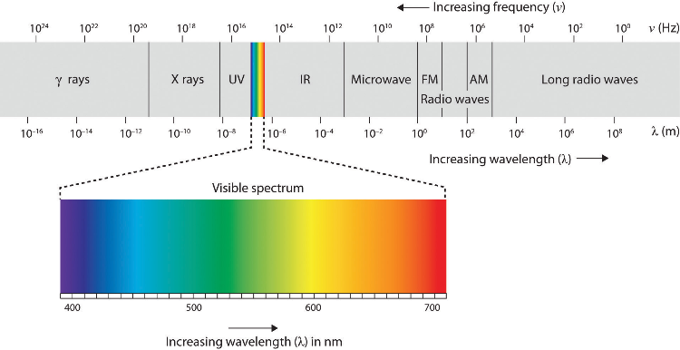

|  |  |
| --- | --- |
| **Element:** | **Approximate emitted wavelength range (nm)** |
| Strontium | **690 – 710 nm** |
| Calcium | **630 – 670 nm** |
| Potassium | **400 – 440 nm** |
| Sodium | **590 – 610 nm** |
| Copper | **510 – 540 nm** |

End of Validation Test